

­­­­­DOCUMENT APPROVAL SHEET

RISK & UNCERTAINITY IN VACATION PLANNING

gold boundless bar

**DOCUMENT IDENTIFICATION:**

MSBA AY 21-22/ RISK & UNCERTAINITY IN VACATION PLANNING

**DOCUMENT AUTHOR:**

|  |  |  |  |  |  |
| --- | --- | --- | --- | --- | --- |
| **AUTHORED BY/ ID** | **SECTION** | **DEPT./ ROLE** | **COHORT** | **CHECKED BY** | **DATE** |
| Teja Alluru  (1150077) | Calculations/  Analysis | MSBA/ Student | 2021-2022 | Teja Alluru  (1150077) | 12-March-2022 |

**DOCUMENT APPROVAL:**

|  |  |  |  |  |
| --- | --- | --- | --- | --- |
| **APPROVED BY/ ID** | **DEPT.** | **SCHOOL** | **SIGNATURE** | **DATE** |
| Teja Alluru (1150077) | MSBA/ Student | University of Washington, Tacoma, Milgard School of Business |  | 06-March-2022 |

*AUTHORED BY: Authored by mean of a person/entity responsible for the creation of the document.*

*APPROVED BY: Approval means a person/entity responsible for the approval of the document content.*

INDEX OF CONTENTS

gold boundless bar

DOCUMENT APPROVAL SHEET 1

INDEX OF CONTENTS 3

INDEX OF FIGURES 4

INDEX OF TABLES 4

1 PROJECT INFORMATION 5

2 PROJECT INFORMATION 6

2.1 Project Background 6

2.2 Project Significance 7

2.3 Project Statement/Objective 7

2.4 Decision Alternatives 7

2.5 Figural Model of Decision Process 7

3 PROJECT RESEARCH 9

3.1 Research Methodology 9

3.2 Evaluation Methods & Evaluation Measures 9

3.3 Scenarios 10

4 PROJECT DATA 11

4.1 Location Preference Data 11

4.2 Covid Data 12

4.3 Flight Cancellation Data 14

4.4 Trip Cost Data 15

4.5 Project Data Summary -Model 1 16

4.6 Project Data Summary -Model 2 16

5 PROJECT MODEL 17

5.1 Model Tree – Model 1 17

5.2 Significant Decision Nodes – Model 1 20

5.3 Model Tree – Model 2 20

5.4 Significant Decision Nodes – Model 2 21

6 CONCLUSION 21

7 SENSITIVITY ANALYSIS 22

8 Next Steps 26

9 REFERENCES 26

INDEX OF FIGURES

gold boundless bar

Figure 2‑1: Sample Decision Tree Ref.[1] 6

Figure 2‑2: Figural Model of Decision Process (Sample) 8

Figure 4‑1: Travel Destination data 11

Figure 4‑2: RTPcr Confusion Matrix 12

Figure 4‑3: Naïve Bayes Rule to Calculate Covid Data 13

Figure 4‑4: Flight Cancellation Data 14

Figure 4‑5: Trip Cost Data- All Expenses Included 15

Figure 5‑1: Precision Tree -International Travel– Model 1 17

Figure 5‑2: Precision Tree – National & Local Travel– Model 1 18

Figure 5‑3: Precision Tree – Model 1 19

Figure 5‑4: Precision Tree -International Travel– Model 2 20

Figure 5‑5: Precision Tree – National & Local Travel– Model 2 21

Figure 7‑1: Precision Tree – Sensitivity Analysis 1– Model 2 22

Figure 7‑2: Precision Tree – Sensitivity Analysis 2– Model 2 23

Figure 7‑3: Precision Tree – Sensitivity Analysis 3– Model 2 24

Figure 7‑4: Precision Tree – Sensitivity Analysis 3– Model 2 25

INDEX OF TABLES

gold boundless bar

Table 4‑1: Covid Data 12

Table 4‑2: Calculated Covid Data USA 13

Table 4‑3: Project Data Summary – Model 1 16

Table 4‑4: Project Data Summary – Model 2 16

# PROJECT INFORMATION

gold boundless bar

**COURSE NAME:** TBANLT 550 Analytical Decision Making

**QUARTER:** Winter 2022

**STUDENT NAME:** Marion C LaRocque (1464618), Shilpi Karmakar (2110131), Shephali Jain (2110257), Shalini Bagadhi (2110132), Teja Alluru (1150077)

**DATE:** 06-March-2022

**TEAM NAME:** Team 5

**FINAL PROJECT TITLE:** Risk & uncertainty in vacation planning

**INTEGRITY STATEMENT:**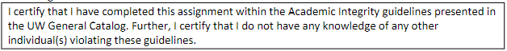

**SIGNATURE:**

| **Last Name, First Name** | **Signature** | **Date** |
| --- | --- | --- |
| Kiran Tejaswi (Teja) Alluru |  | 13-March-2022 |
| Shephali Jain |  | 13-March-2022 |
| Marion LaRocque |  | 13-March-2022 |
| Shilpi Karmakar​ |  | 13-March-2022 |
| Shalini Bagadhi |  | 13-March-2022 |

# PROJECT INFORMATION

gold boundless bar

## Project Background

There have been risks and uncertainty in travel/vacation planning for ages. But with major events like the terror attacks of September 11th, 2001, or the coronavirus pandemic from Jan 2020 there has been an increase in risk and uncertainty in vacation planning. There are many aspects of uncertainties of future events like the travel lockdowns due to new variant of coronavirus or a major risk of conflict between Russia and Ukraine and its uncertainty in being blown into a full-scale war etc., Apart from these global travel uncertainties we have other uncertainties like where to go for vacation, whether to go for a weekend getaway or a long vacation, uncertainty of the weather, uncertainty in budget/travel costs, the uncertainty of becoming sick on the day of travel, whether to go on a vacation to visit family or visit new tourist places, etc. Since there are so many uncertainties in planning a vacation, it becomes particularly important to understand the probability of outcomes or uncertainties to better mitigate the risk. A sample decision tree for vacation planning decision-making is shown in Figure 2‑1.

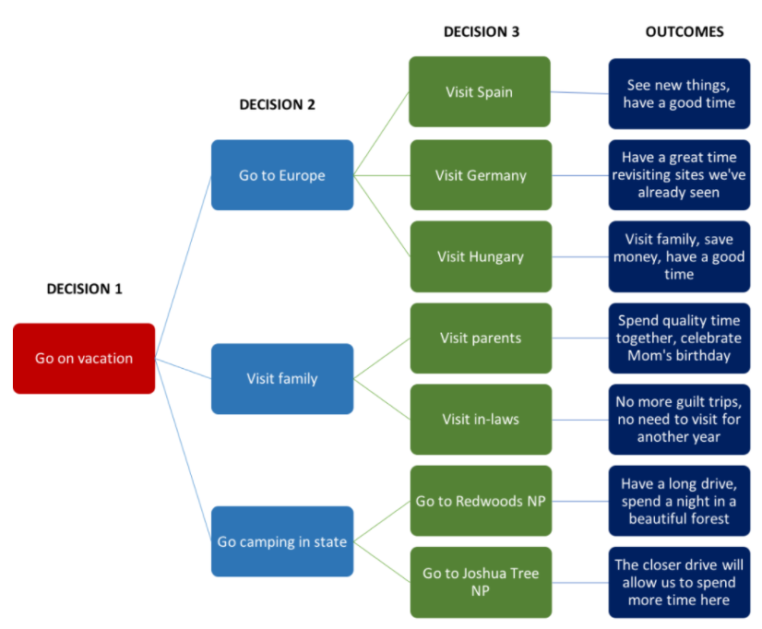

Figure 2‑1: Sample Decision Tree Ref.[1]

## Project Significance

Everyone wants to have a great vacation to remember for life where they can spend some time off work relaxing and spending time joyfully. It often happens that people plan the vacation and due to various uncertainties, the vacation planning becomes more of a stressful event than being a joyful event. Therefore, it becomes incredibly significant to identify the uncertainties involved in vacation planning and the risks associated with it. The more information available regarding the uncertainties in vacation planning the better the planner is equipped to deal with a successful decision which would result in a higher probability of a joyful vacation. The project is undertaken to understand several factors that significantly influence the decision-making in planning for a vacation.

## Project Statement/Objective

The objective of the project is to create a decision tree model for the uncertainty in vacation planning. The project involves selecting the most significant variables/decision nodes and the corresponding probabilities and uncertainties involved with each decision node.

Since the scope of the project is very broad and can be pursued further depending on resource and time availability, the team has decided to make a model which has a scope for extension in case the team wants to pursue it for its research paper.

## Decision Alternatives

Three alternatives are chosen for decision making which is given below.

* Go on an international trip
* Go on a national trip and
* Go on a local trip to visit family

The probability is assigned to an international trip, then national and then family. We assume that due to covid the family has been unable to travel abroad for a lot of time and therefore we intend to give priority to international travel. Based on destinations chosen and the preference of the family probability of travel to certain decisions is fixed.

## Figural Model of Decision Process

The team has come up with two plans initially to execute our project. The details of the plan are listed below and the sample figural model of the project decision-making is presented in Figure 2‑2.

The initial plan was to create a model with uncertainties of covid and flight cancellation included in the decision tree. After that depending on the time constraint, we will be further pursuing the project to include a scenario where the decision is made to go to a particular decision and what happens if you catch covid at the destination, is it advisable to take full cover covid insurance travel plan to safeguard your trip from uncertainties or not.

**Model 1** (Elaborate model, as shown in Figure 21 above). Since the model would need significant time and research. This is subject to our team member's availability for this work.

**Model 2** (Simple multistage stage model, as discussed in office hours) This model is a simple model where the travel uncertainties would be obtained from the following two websites:

COVID cases in recent days: <https://ourworldindata.org/coronavirus/country/united-states>

Flight cancelation % recent: <https://flightaware.com/live/cancelled/>

Vacation cost estimates from: [www.expedia.com](http://www.expedia.com)

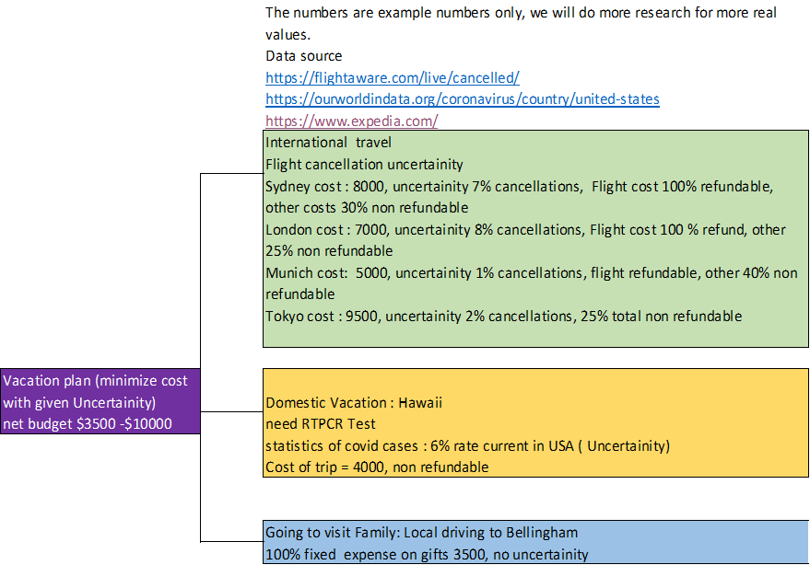

Figure 2‑2: Figural Model of Decision Process (Sample)

Conclusively, project scope can go out of capacity in terms of resource and time constraints of the applicable quarter timeline, so the “Plan 2: Simpler model” mentioned in the above figure with specific scenarios and associated uncertainties are finalized for scope freeze of the project objective.

# PROJECT RESEARCH

## Research Methodology

For undertaking the real-time data with authenticity, the well-known sites are explored and accessed for thorough research and analysis purposes. The information is presented in the yellow highlighted tabs in the excel file “Travel Cost and Probabilities Model 1.xlsx”

* Based on the top 10 vacation destinations to visit for family (domestic) or for tourism (international), researched through google search engine and took preferred results for selecting the destinations for our model. (Refer to the Excel sheet: Destination Data)
* Probability to destinations is assigned based on preference.
* To understand price volatile patterns concerning places, seasonality, and different time of the year for vacation packages, we extracted data from: <http://www.expedia.com/>
* For COVID Cases (rise/decline in percentage) in the USA, we have referred to: <https://ourworldindata.org/coronavirus/country/united-states> and <https://ourworldindata.org/>
* To define the proper source of uncertainty statistics for airline cancellation, we have utilized the live streaming website: <https://flightaware.com/live/cancelled>
* There are several sources of data collected and each of the references where the data is collected from is mentioned in the excel file.
* Note: The figures might be revised and updated based on the progress of the project being dynamic.

## Evaluation Methods & Evaluation Measures

The team has chosen the precision tree method to analyze the spring vacation decision-making under uncertainty. Two different evaluation measures were utilized to arrive at decisions for our model. One was the probability of the decision and consecutive chance node, other was the EMV value based on the cost and probabilities combined.

Sensitivity analysis was carried out by varying the uncertainty probability in the covid test positive rate and the flight cancellation rate. Also, the Naïve Bayes was utilized to calculate the total RTPcr test positive rate of a country depending on the positive cases in the country and the confusion matrix of the RT-PCR test. This is done as most flight travel requires to get the RTPcr test and no other test.

## Scenarios

Mr. John Smith and his family currently live in Seattle WA, USA, and want to go for a vacation in Spring/Summer 2022. He is thinking of one of the following possible options.

1. **Visit Family (No Uncertainty):**

* No uncertainty is involved in this case as the associated cost constraints are known.
* They can visit his parents in Bellingham, WA. Whenever he visits his parents, he brings $3000 worth of gifts and spends $500 on travel and food on his way.

1. **Domestic Travel (Uncertainty from COVID test):**

* Mr. Smith and his family can go for a vacation in San Diego, SAN. However, they need to take an RT PCR test 72 hours (about 3 days) before the flight departs from Sea-Tac. Based on the recent Covid increase, currently, USA covid infection rate is 1.32%. His San Diego hotel cost is $x, Flight Cost is $y and the total cost is $2,324.00. However, the Hotel booking needs to be done beforehand and is partially refundable because of seasonal demand. His flight booking is refundable if he produces a positive Covid result.
* Sensitivity analysis will be performed on the following as we obtain dynamic values which will help in identifying the calculated possibilities of the outcome:
  + What if the covid cases decrease or increase: 0%-50%
  + Flight Cancellations (rise/decline): 0% - 50%

**International location (Uncertainty from COVID**)

If Mr. Smith chooses to spend his vacation internationally, he would have to book the flights (considering a single mode of transportation for ease of assumptions). However, due to Covid the flight is uncertain and could be canceled. The number of funds required/returned and corresponding probabilities of flight cancellations are listed in Table 3-1 Final Research Data.

Similarly, to their domestic travel, sensitivity analysis will be performed for changed probabilities of flight cancellations and increase in covid cases.

**Summary tasks to be performed as part of the analysis:**

Above mentioned three scenarios will be performed based on the following:

* Use of Precision Tree analytical method to identify the scenario which minimizes the fund loss for Mr. John Smith and is the best-case scenario to opt given monitory constraint as a decision variable.
* Perform a sensitivity analysis on the optimal decision.

# PROJECT DATA

The data collection involved collecting the following data.

* Location Preference
* Covid data
* Flight cancellation data
* Travel Cost Data

## Location Preference Data

The location preference data is researched from Usnews.com and the data along with the preferences selected is presented in Figure 4‑1



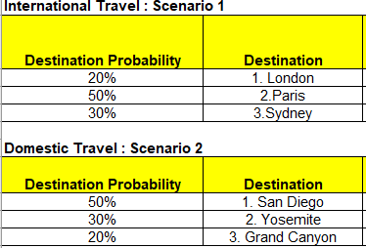

Figure 4‑1: Travel Destination data

## Covid Data

The covid data on the source and destination locations are obtained from https://ourworldindata.org/ and summarized in Table 4‑1 below.

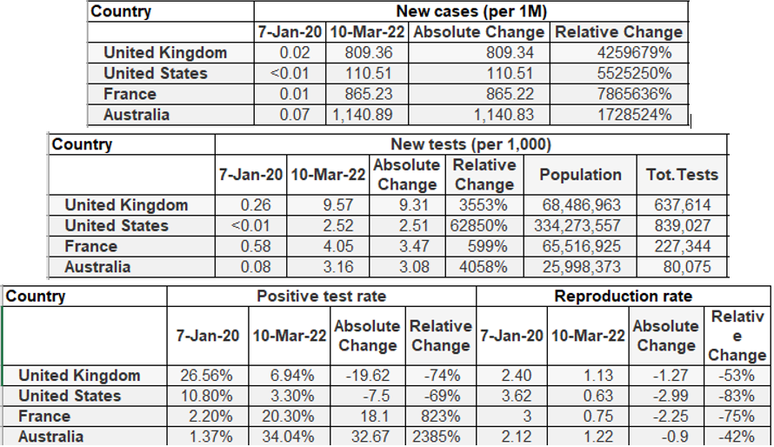

Table 4‑1: Covid Data

The test positivity rate of the RTPcr data was collected from [https://www.researchgate.net/figure /Confusion-Matrix-for-Covid-19-Detection-using-CNN-with-synthetic-data-augmentation-and_fig5_ 341401062](https://www.researchgate.net/figure%20/Confusion-Matrix-for-Covid-19-Detection-using-CNN-with-synthetic-data-augmentation-and_fig5_%20341401062) and is presented in Figure 4‑2 below

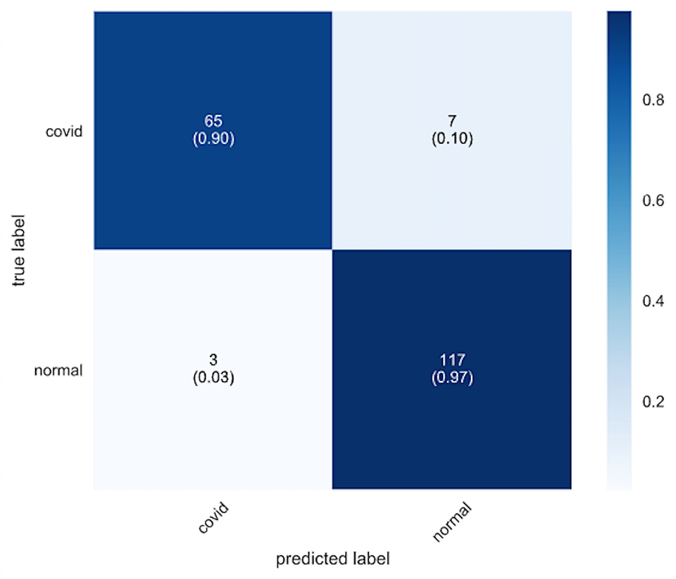

Figure 4‑2: RTPcr Confusion Matrix

The Naïve Bayes method is used to calculate the covid test positive probability. This is done to get the accurate probability that can be used for the project. The calculations for all regions are presented in excel and the calculation for the USA are shown in Figure 4‑3 and Table 4‑2: Calculated Covid Data USA and below.

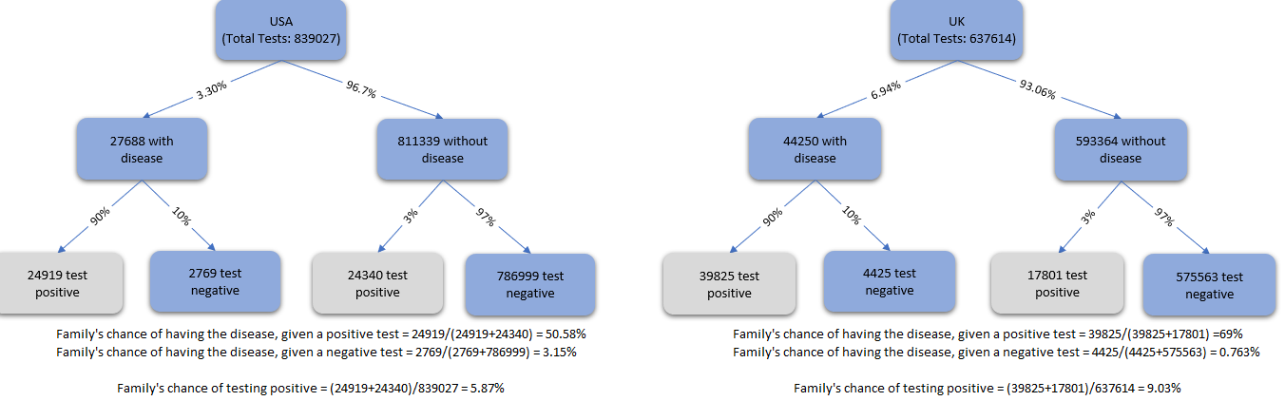

Figure 4‑3: Naïve Bayes Rule to Calculate Covid Data

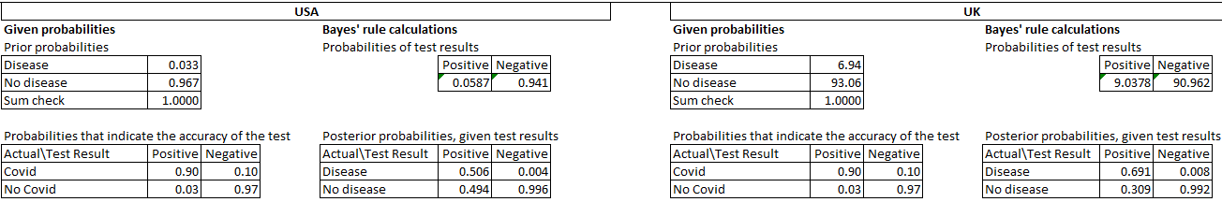

Table 4‑2: Calculated Covid Data USA

## Flight Cancellation Data

The domestic flight cancellation data was collected from [https://www.transtats.bts.gov/HomeDrill Chart.asp](https://www.transtats.bts.gov/HomeDrill%20Chart.asp) and the international flight data was collected from <https://flightaware.com/live/cancelled/>.

Where the statistics of the destination location are not known the data for the original location is considered. The flight cancellation data for Seattle is shown in Figure 4‑4.

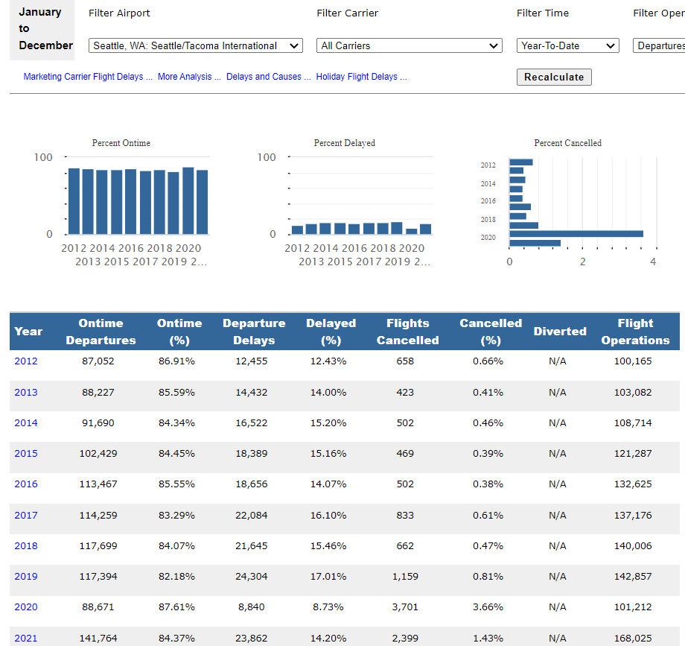

Figure 4‑4: Flight Cancellation Data

## Trip Cost Data

The trip cost data were collected from <https://www.expedia.com/>. The trip cost data from Seattle to London is shown in Figure 4‑5.

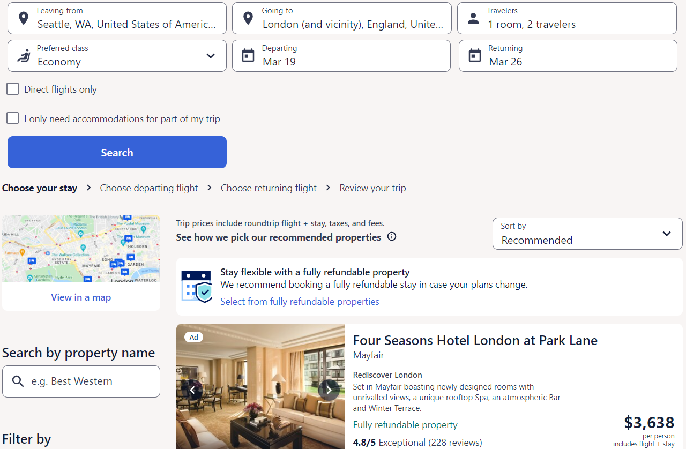

Figure 4‑5: Trip Cost Data- All Expenses Included

## Project Data Summary -Model 1

The project data used for the analysis are summarized and presented in Table 4‑3 below.

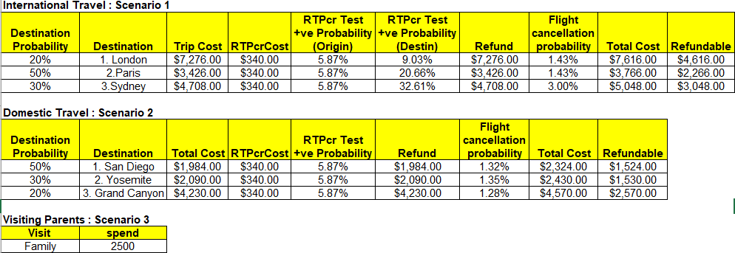

Table 4‑3: Project Data Summary – Model 1

## Project Data Summary -Model 2

The project data used for the analysis are summarized and presented in Table 4‑4 below.

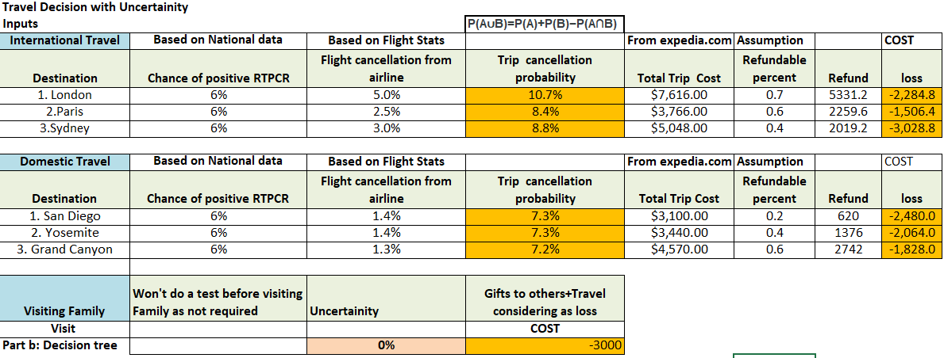

Table 4‑4: Project Data Summary – Model 2

# PROJECT MODEL

## Model Tree – Model 1

The precision tree for model-1 for our project is presented in Figure 5‑3 below. For clarity, Figure 5‑1 and Figure 5‑2 below show the screenshots of the international travel tree and the national/local travel tree.

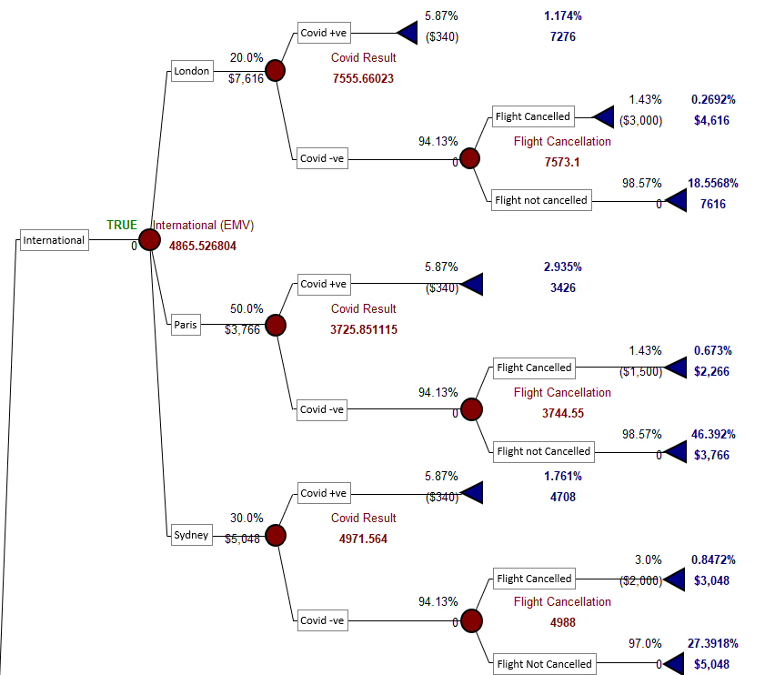

Figure 5‑1: Precision Tree -International Travel– Model 1

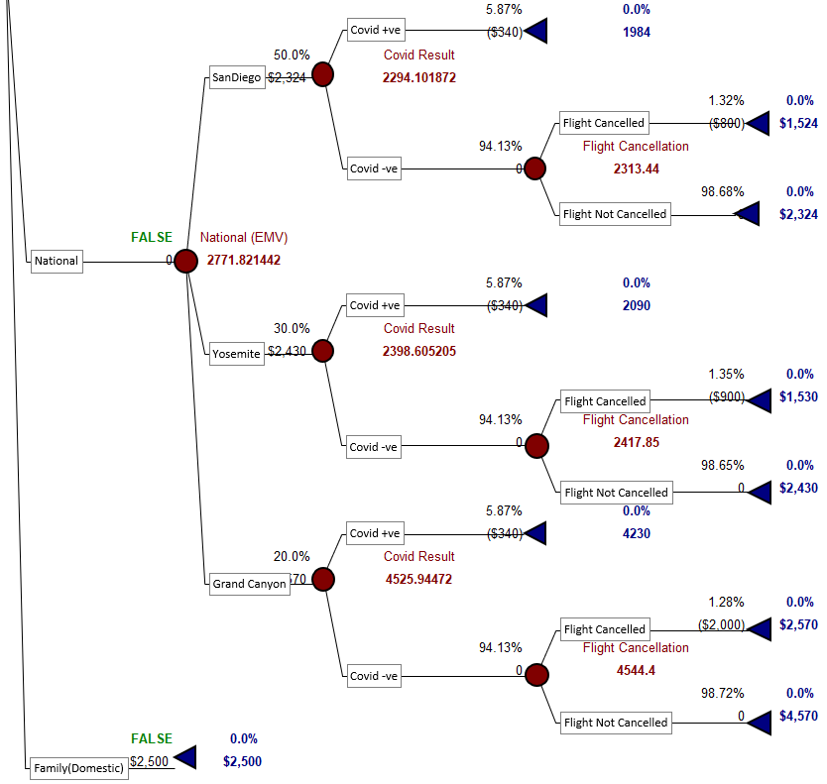

Figure 5‑2: Precision Tree – National & Local Travel– Model 1

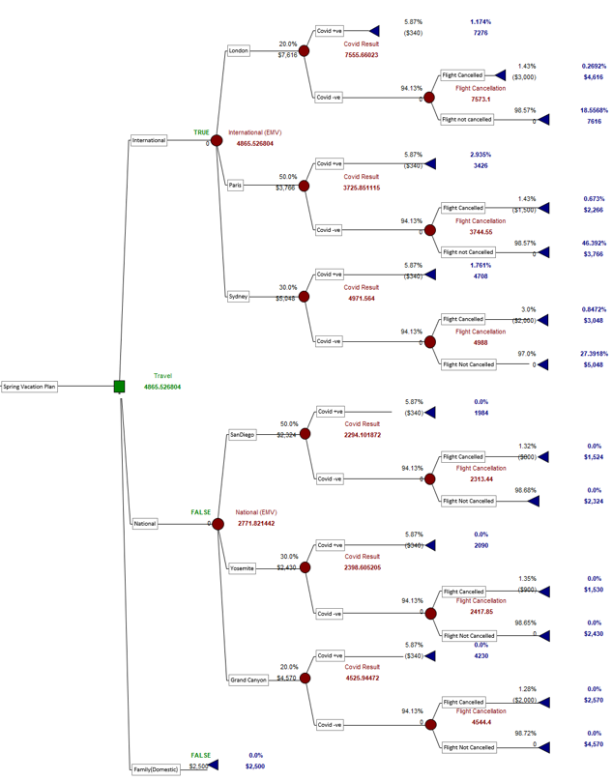

Figure 5‑3: Precision Tree – Model 1

## Significant Decision Nodes – Model 1

The travel is first divided into three nodes international, domestic, and family. The international and the domestic travel are then further divided into three respective decision nodes and the probability is assigned to them based on the cost of the trip. Then each destination is further having a chance node of covid +ve and covid -ve. If covid is +ve the trip is canceled and the only cost accrued will be the cost of the RT-PCR test which is $340 for the family. If covid is negative then there is another chance node that has flight canceled on not canceled. If the flight is canceled then there will be only a certain amount refunded and flight is not canceled then we will need to spend the complete amount for the trip.

## Model Tree – Model 2

The precision tree for model-1 for our project is presented in Figure 5‑3 below. For clarity, Figure 5‑1 and Figure 5‑2 below show the screenshots of the international travel tree and the national/local travel tree.

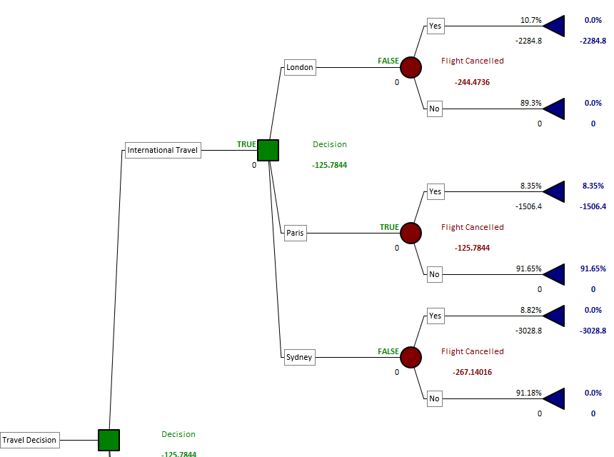

Figure 5‑4: Precision Tree -International Travel– Model 2

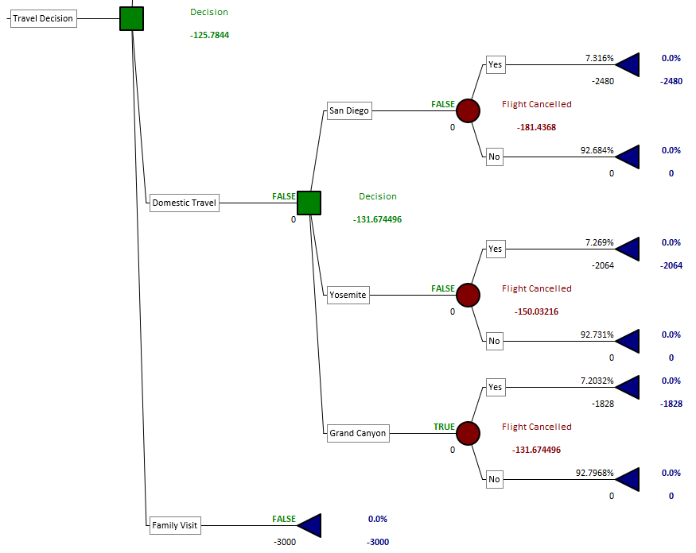

Figure 5‑5: Precision Tree – National & Local Travel– Model 2

## Significant Decision Nodes – Model 2

The difference between model 1 and model 2 is that the node covid test positive rate is removed and cumulative trip cancellation probability was calculated based on flight cancellation rate and covid test positive rate. Some of the flight cancellation rates and covid rates have changed due to the consideration of real-time data.

# CONCLUSION

Based on the decision trees of model 1 and model 2. Model 2 was considered for its simplicity of explanation. From model 2 the best destination was found to be the trip to Paris and sensitivity analysis was carried out further on model 2.

# SENSITIVITY ANALYSIS

The following four sensitivity analysis

Sensitivity: 1. What happens if the trip cancellation probability of Paris varies +/- 50% of the base value.?

Tab: Strategy D6: International travel is still the best option as long as Paris trip cancellation probability is less than around 9.2%, if higher, preferred domestic. See Figure 7‑1 below.

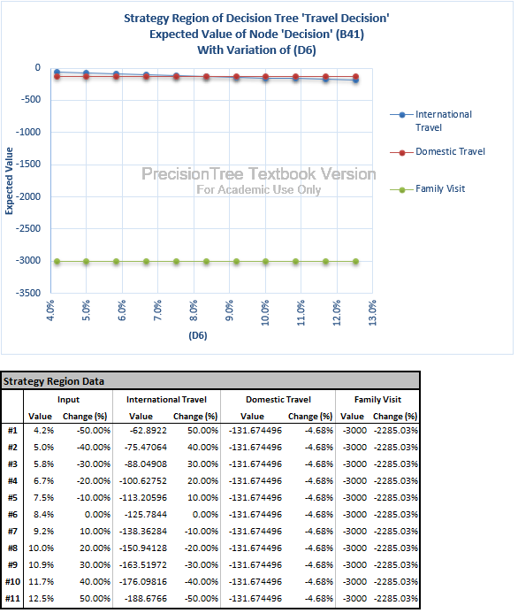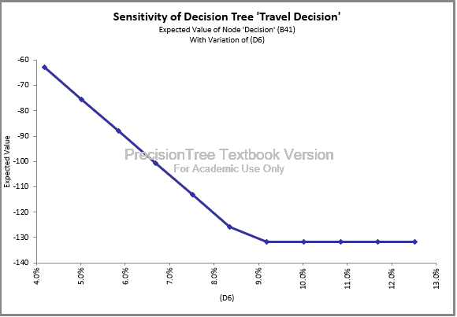

Figure 7‑1: Precision Tree – Sensitivity Analysis 1– Model 2

Sensitivity 2: Two way: Trip cancellation probability 1-10% and Refund 0.1-0.8% for Grand Canyon

Please see tab: Strategy Region D13, F13. Interesting point. If the refundable percent is 70% and above Grand Canyon is preferred Even if the Trip cancellation probability is 10%. See Figure 7‑2 below

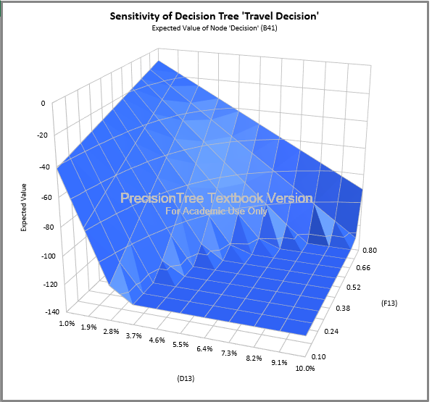

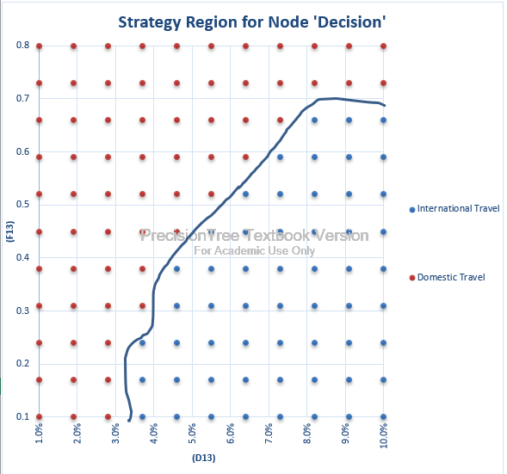

Figure 7‑2: Precision Tree – Sensitivity Analysis 2– Model 2

Sensitivity 3: What if John Smith does not need to take a gift? Only road trip cost 50 -500 USD

Tab: Strategy D17: Family Visit would be the best option if John Smith does not buy gifts for the family and keep the trip cost to less than $125. See Figure 7‑3 below.

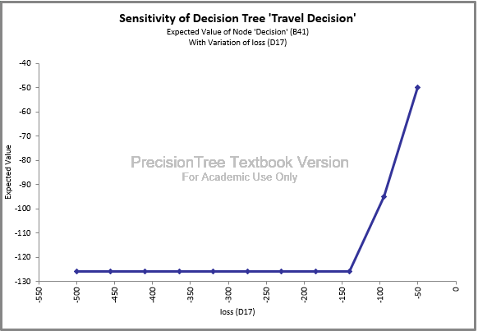

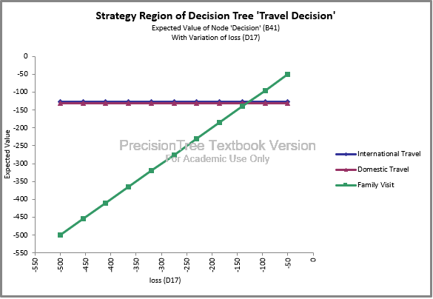

Figure 7‑3: Precision Tree – Sensitivity Analysis 3– Model 2

Sensitivity: 4. Two Way: What happens if the trip cancellation probability of London varies +/- 50% of the base value. And refund varies between 0.6 to 0.9? Is Paris still preferred?

Tab: Strategy region D5 F5: Shows the ranges of Trip cancellation and Refund values when London is preferred. For example, for the current refund rate (0.7), if the trip cancellation is less than 6%, London would be preferred. See Figure 7‑4 below.

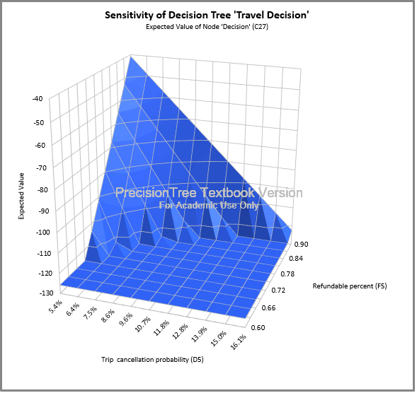

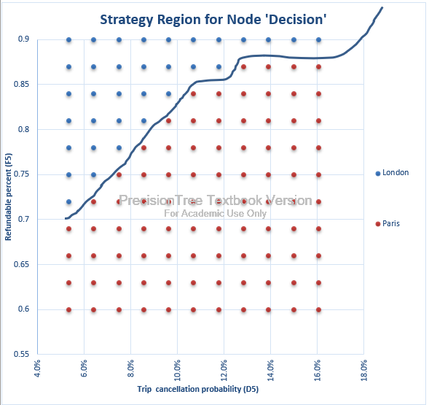

Figure 7‑4: Precision Tree – Sensitivity Analysis 3– Model 2

# Next Steps

The team can achieve only what was done till Section 6 due to limited timeframe and resources. Going forward the team wanted to pursue two major items in the project on which partial work was done. The two major items are listed below.

* What is the uncertainty involved if we catch covid after reaching the destination? What is the cost effect involved?
* Depending on the cost effect calculated above, is it advisable to take a full covid travel insurance coverage or not?

# REFERENCES

1. <https://courses.lumenlearning.com/suny-principlesmanagement/chapter/using-a-decision-tree/>